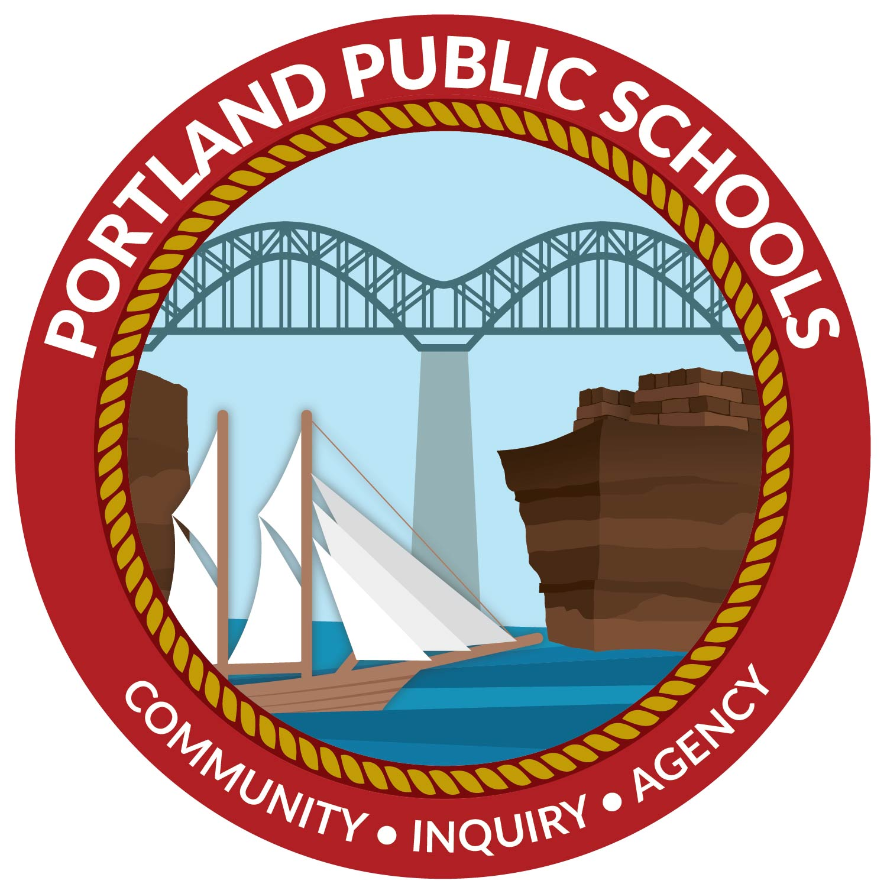 | Portland Public Schools  BOE Curriculum Subcommittee Meeting  February 21, 2024

Meeting Agenda (Virtual) @ 3:30pm
Virtual Meeting Link: meet.google.com/cfi-pwhx-hbe

- PHS English Elective Course Proposal - Mystery and Mayhem

- PHS History Elective Course Proposal - Contemporary Issues through Multimedia

- CSDE State Personnel Development Grant Opportunity

Next Meeting: March 20, 2024

