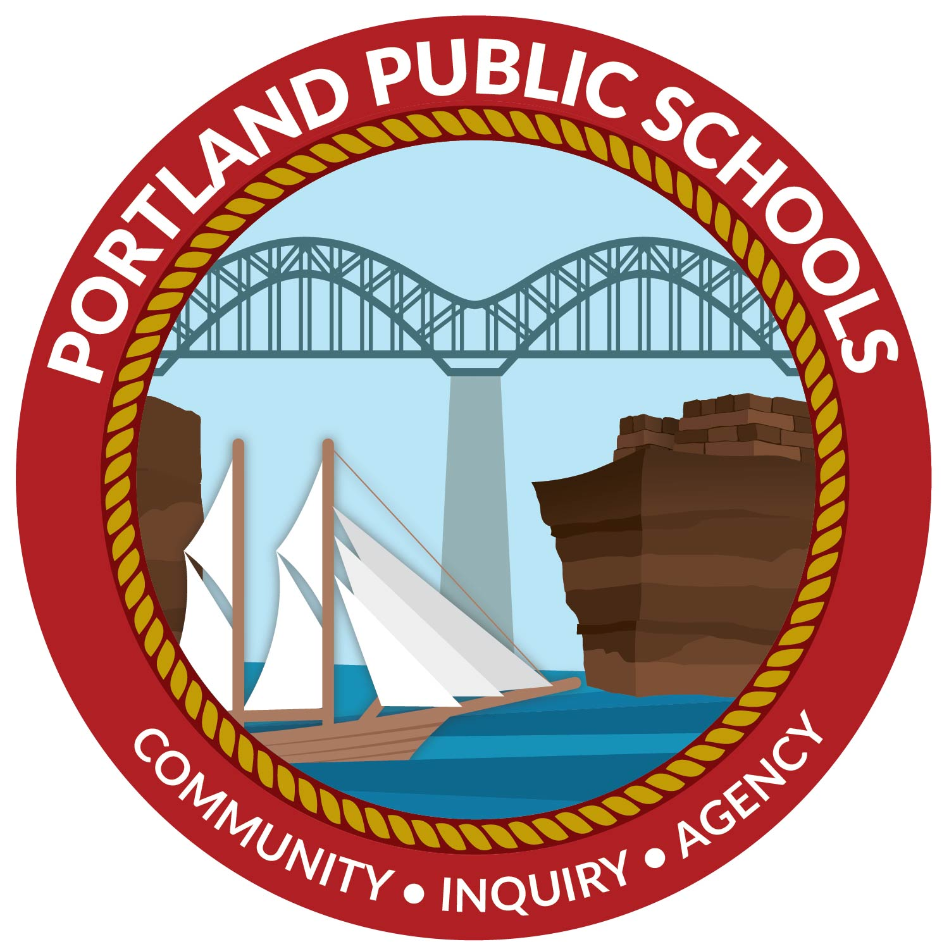 | Portland Public Schools  BOE Curriculum Subcommittee Meeting  August 16, 2023

Meeting Agenda (Virtual) @ 2:30pm
Virtual Meeting Link: meet.google.com/qfw-zyfc-wmv

- Proposed Mathematics Research Study at Portland High School

Next Meeting: September 2023 (Date TBD)

